# 1. INTROUDCTION

* 1. OVERVIEW
* Description of the project

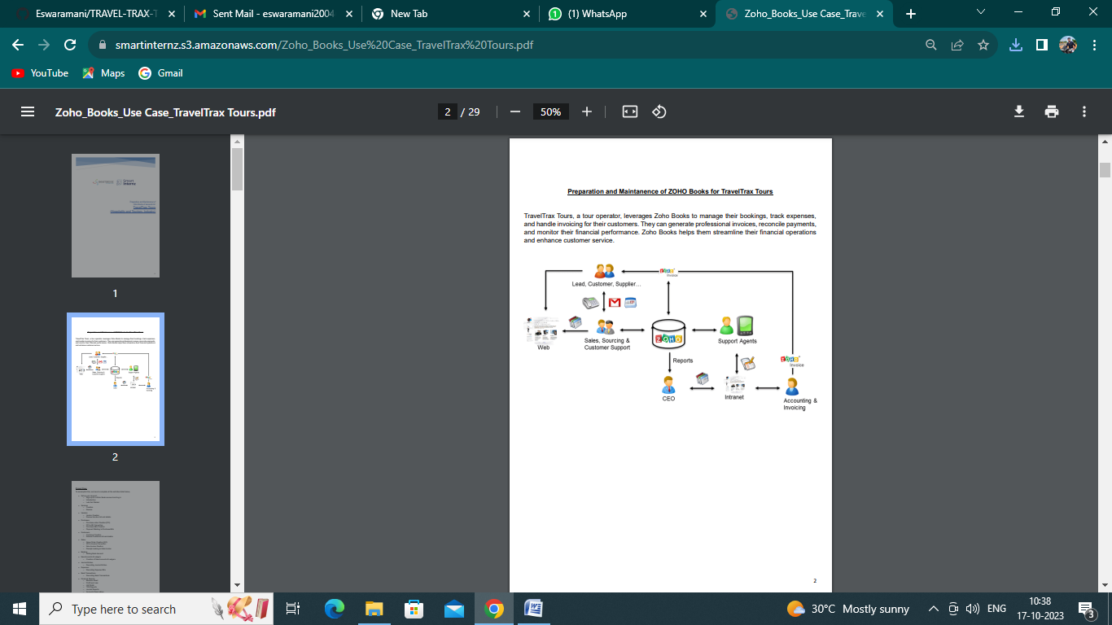

# 2. Problem definition & design Thinking

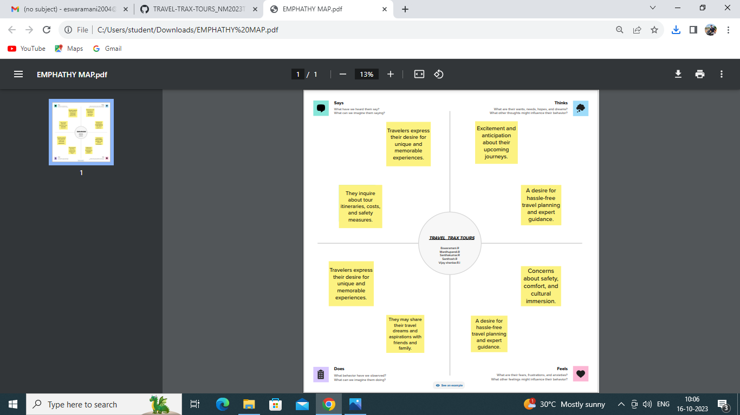 2.1 Empathy map

2.2 Ideation & Brainstorming map

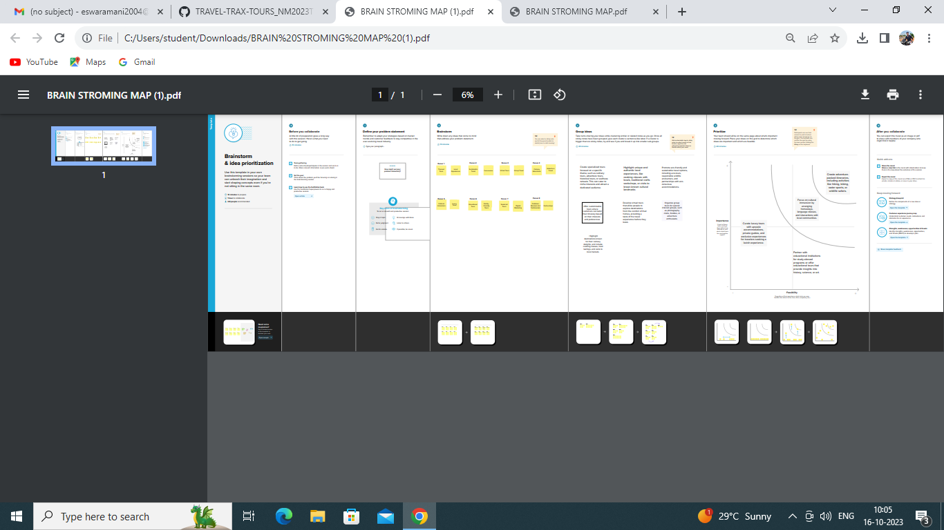

3. RESULT

PROFIT & LOSS

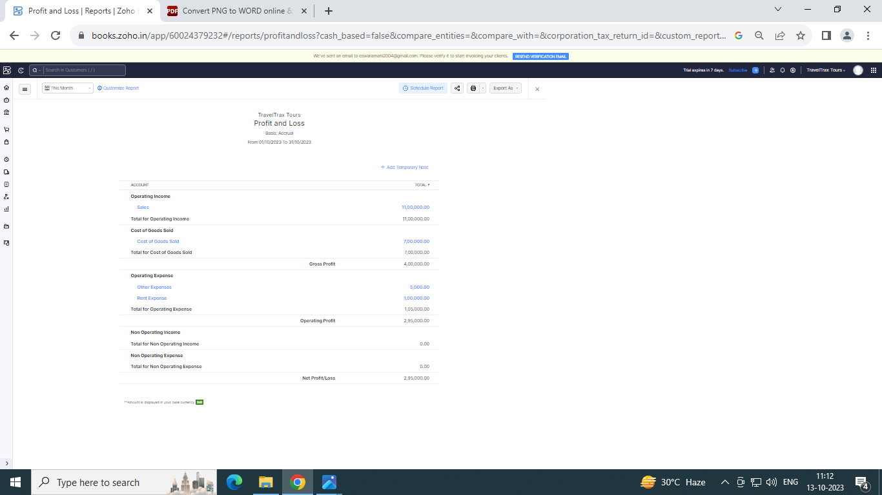

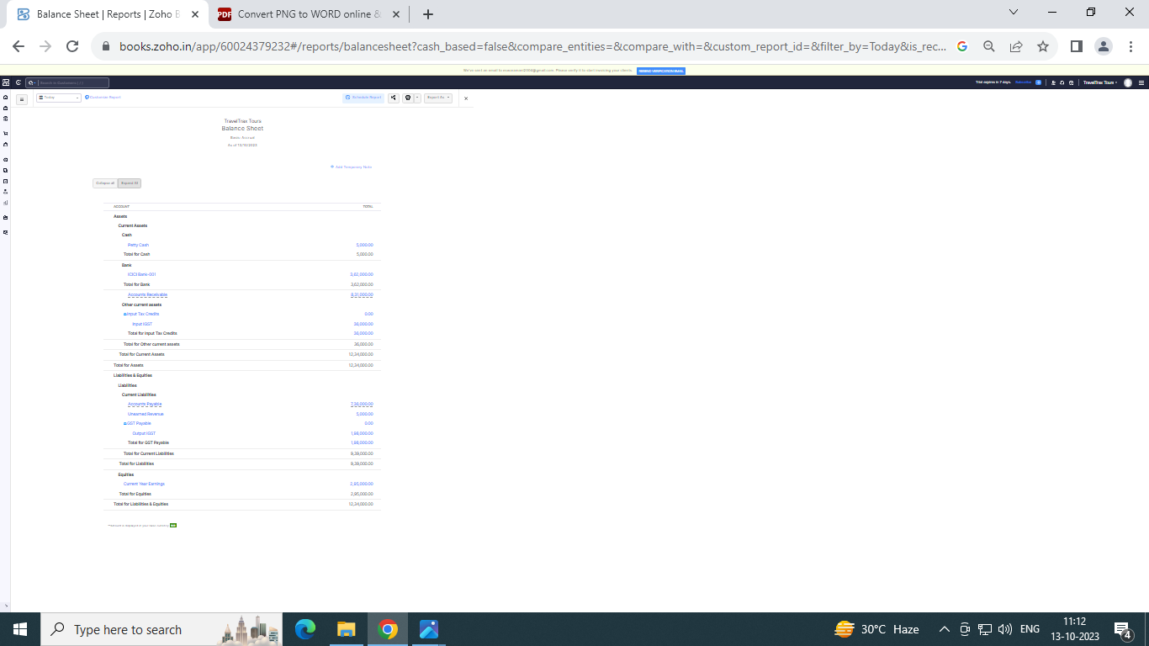BALANCE SHEET :

Purchase order :

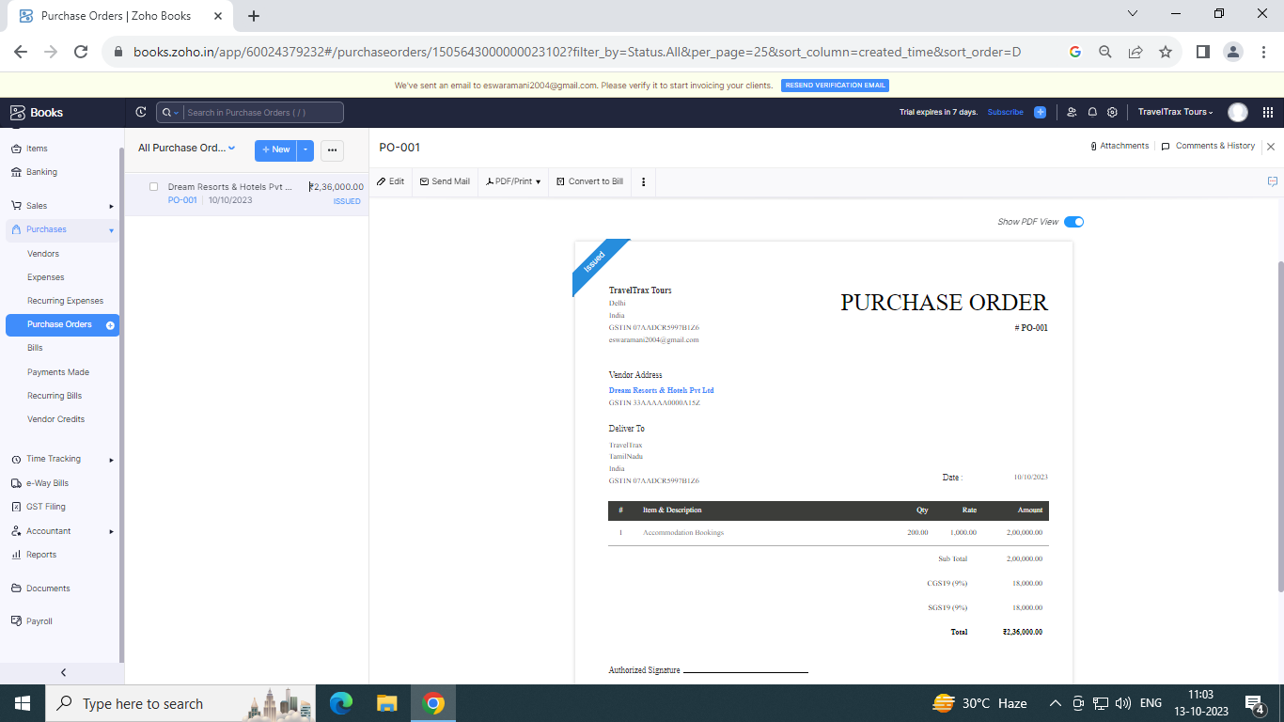

BILLS :

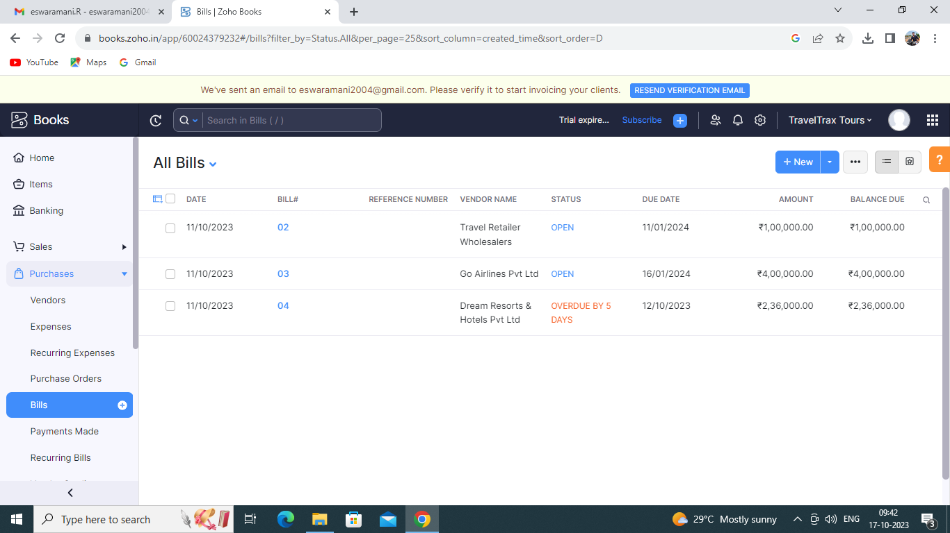

SALES ORDER :

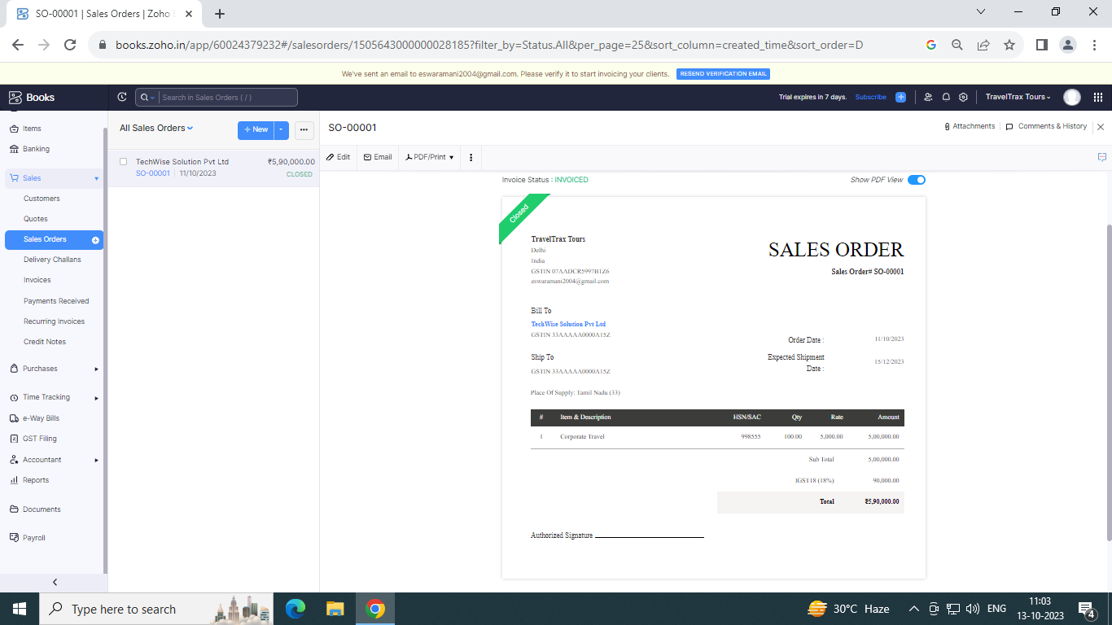

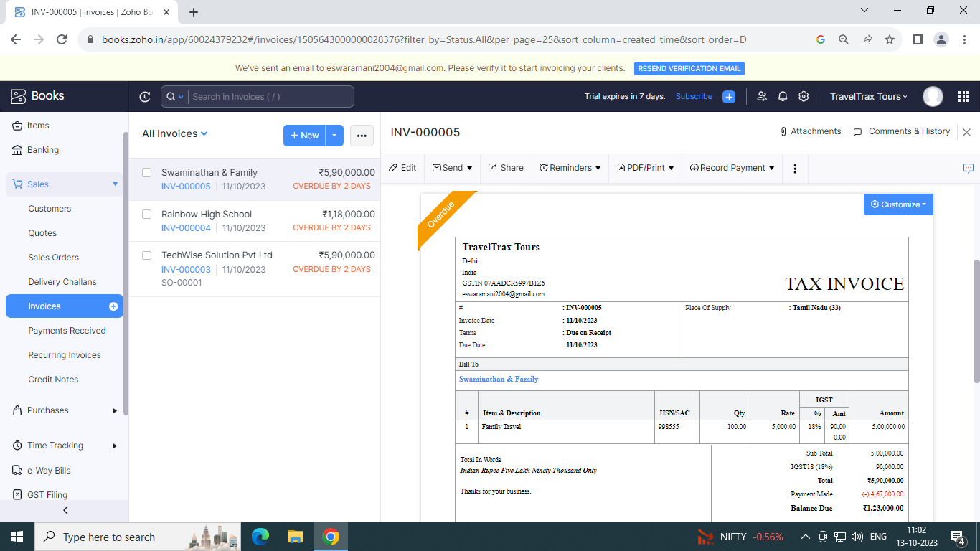INVOICE :

**Advantages:**

*One of the biggest advantages is of course the convenience. As earlier suggested, planning for a full-fledged trip and visiting various places will take quite a lot of planning and due diligence. But when you opt for a tour package, you can just sit back and relax — at least as far as planning is concerned.

*Tour packages can be a great option when you are looking to plan a honeymoon or travel with your family. A poorly planned trip can be quite embarrassing as well as stressful; therefore, going with a reputable travel company might be a safer option.

*Safety is another big advantage of tour packages. When you are doing the planning, and choosing the destinations or activities to do, you might pick out a place or activity that might have some potential risks that you’d rather avoid. Travel companies know places inside out, and they will usually choose risk-free destinations and activities, keeping in mind the age and preferences of the participants.

**Disadvantages:**

**\***The biggest disadvantage of a tour package is the lack of control. You need to follow the guidelines and a strict schedule. You cannot extend your stay in a certain place even if you love it. Similarly you cannot move to the next place if there’s nothing to be excited about, before the scheduled time.

*You need to be extra careful while choosing one of these packages. The aforementioned advantages can easily turn into disadvantages if you don’t choose the right company.

# 5. APPLICATION :

TRAVELTRAX AND TOURS

# 6. CONCLUSION :

As we have seen in this chapter, tourism is a complex system that is built up of industry sectors including accommodation, recreation and entertainment, food and beverage services, transportation, and travel services. It encompasses domestic, inbound, and outbound travel for business, leisure, or other purposes. And because of this large scope, tourism development requires participation from all walks of life, including private business, governmental agencies, educational institutions, communities, and citizens.

# 7. FUTURE SCOPE :

Many travel professionals have adapted to this new environment by working for independent contractor companies or choosing to join host agencies. So it seems in one form or another, travel agents will survive! It's likely they will continue to evolve and serve an ever-changing world of travel.

# 8.APPENDIX :

## https://github.com/Eswaramani/TRAVEL-TRAX-TOURS_NM2023TMID22840

|  |
| --- |
| <!DOCTYPE html> |
|  | <html lang="en" data-color-mode="auto" data-light-theme="light" data-dark-theme="dark" data-a11y-animated-images="system" data-a11y-link-underlines="false"> |
|  |  |
|  | <style> |
|  | /* for each iteration, uncomment the CSS variable */ |
|  |  |
|  | /* light themes */ |
|  | [data-color-mode="light"][data-light-theme*="light"], |
|  | [data-color-mode="auto"][data-light-theme*="light"] { |
|  | /* iteration 1 */ |
|  | --border-color-iteration-1: #C8CCD0; |
|  | /* iteration 2 */ |
|  | --border-color-iteration-2: #BABFC5; |
|  | /* iteration 3 */ |
|  | --border-color-iteration-3: #A6ADB4; |
|  | /* iteration final */ |
|  | --border-color-iteration-4: #868F99; |
|  |  |
|  | /* the first value is the final step, which falls back to previous iterations */ |
|  | --control-borderColor-rest: var(--border-color-iteration-4, var(--border-color-iteration-3, var(--border-color-iteration-2, var(--border-color-iteration-1)))) !important; |
|  | } |
|  |  |
|  | /* dark themes */ |
|  | [data-color-mode="dark"][data-dark-theme*="dark"], |
|  | [data-color-mode="auto"][data-light-theme*="dark"] { |
|  | /* iteration 1 */ |
|  | --border-color-iteration-1: #363940; |
|  | /* iteration 2 */ |
|  | --border-color-iteration-2: #3F434B; |
|  | /* iteration 3 */ |
|  | --border-color-iteration-3: #4B5159; |
|  | /* iteration final */ |
|  | --border-color-iteration-4: #666E79; |
|  |  |
|  | /* the first value is the final step, which falls back to previous iterations */ |
|  | --control-borderColor-rest: var(--border-color-iteration-4, var(--border-color-iteration-3, var(--border-color-iteration-2, var(--border-color-iteration-1)))) !important; |
|  | } |
|  |  |
|  | [data-color-mode="dark"][data-dark-theme="dark_dimmed"], |
|  | [data-color-mode="dark"][data-dark-theme="light_high_contrast"], |
|  | [data-color-mode="dark"][data-dark-theme="dark_high_contrast"], |
|  | [data-color-mode="light"][data-light-theme="dark_dimmed"], |
|  | [data-color-mode="light"][data-light-theme="light_high_contrast"], |
|  | [data-color-mode="light"][data-light-theme="dark_high_contrast"] { |
|  | /* skip these themes, use the fallback */ |
|  | --control-borderColor-rest: initial !important; |
|  | } |
|  |  |
|  | @media (prefers-color-scheme: dark) { |
|  | /* dark colors in dark mode */ |
|  | [data-color-mode="auto"][data-dark-theme*="dark"] { |
|  | /* iteration 1 */ |
|  | --border-color-iteration-1: #363940; |
|  | /* iteration 2 */ |
|  | --border-color-iteration-2: #3F434B; |
|  | /* iteration 3 */ |
|  | --border-color-iteration-3: #4B5159; |
|  | /* iteration final */ |
|  | --border-color-iteration-4: #666E79; |
|  |  |
|  | /* the first value is the final step, which falls back to previous iterations */ |
|  | --control-borderColor-rest: var(--border-color-iteration-4, var(--border-color-iteration-3, var(--border-color-iteration-2, var(--border-color-iteration-1)))) !important; |
|  | } |
|  |  |
|  | /* light colors in dark mode */ |
|  | [data-color-mode="auto"][data-dark-theme*="light"] { |
|  | /* iteration 1 */ |
|  | --border-color-iteration-1: #C8CCD0; |
|  | /* iteration 2 */ |
|  | --border-color-iteration-2: #BABFC5; |
|  | /* iteration 3 */ |
|  | --border-color-iteration-3: #A6ADB4; |
|  | /* iteration final */ |
|  | --border-color-iteration-4: #868F99; |
|  |  |
|  | /* the first value is the final step, which falls back to previous iterations */ |
|  | --control-borderColor-rest: var(--border-color-iteration-4, var(--border-color-iteration-3, var(--border-color-iteration-2, var(--border-color-iteration-1)))) !important; |
|  | } |
|  |  |
|  | [data-color-mode="auto"][data-dark-theme="dark_dimmed"], |
|  | [data-color-mode="auto"][data-dark-theme="light_high_contrast"], |
|  | [data-color-mode="auto"][data-dark-theme="dark_high_contrast"] { |
|  | /* skip these themes, use the fallback */ |
|  | --control-borderColor-rest: initial !important; |
|  | } |
|  | } |
|  |  |
|  | @media (prefers-color-scheme: light) { |
|  | /* dark colors in light mode */ |
|  | [data-color-mode="auto"][data-light-theme*="dark"] { |
|  | /* iteration 1 */ |
|  | --border-color-iteration-1: #363940; |
|  | /* iteration 2 */ |
|  | --border-color-iteration-2: #3F434B; |
|  | /* iteration 3 */ |
|  | --border-color-iteration-3: #4B5159; |
|  | /* iteration final */ |
|  | --border-color-iteration-4: #666E79; |
|  |  |
|  | /* the first value is the final step, which falls back to previous iterations */ |
|  | --control-borderColor-rest: var(--border-color-iteration-4, var(--border-color-iteration-3, var(--border-color-iteration-2, var(--border-color-iteration-1)))) !important; |
|  | } |
|  |  |
|  | /* light colors in light mode */ |
|  | [data-color-mode="auto"][data-light-theme*="light"] { |
|  | /* iteration 1 */ |
|  | --border-color-iteration-1: #C8CCD0; |
|  | /* iteration 2 */ |
|  | --border-color-iteration-2: #BABFC5; |
|  | /* iteration 3 */ |
|  | --border-color-iteration-3: #A6ADB4; |
|  | /* iteration final */ |
|  | --border-color-iteration-4: #868F99; |
|  |  |
|  | /* the first value is the final step, which falls back to previous iterations */ |
|  | --control-borderColor-rest: var(--border-color-iteration-4, var(--border-color-iteration-3, var(--border-color-iteration-2, var(--border-color-iteration-1)))) !important; |
|  | } |
|  |  |
|  | [data-color-mode="auto"][data-light-theme="dark_dimmed"], |
|  | [data-color-mode="auto"][data-light-theme="light_high_contrast"], |
|  | [data-color-mode="auto"][data-light-theme="dark_high_contrast"] { |
|  | /* skip these themes, use the fallback */ |
|  | --control-borderColor-rest: initial !important; |
|  | } |
|  | } |